**Predicting the Best place to open a new Indian Restaurant and Café in my City Bengaluru**

May 10, 2019

**1. Introduction**

**1.1 Background**

Bengaluru is well known as Bangalore which is the capital city of the state Karnataka which belongs to the country India. Bengaluru used to call has “Garden City” now it has been changes to “Silicon city” for the IT hub and lot of start-ups. Restaurant and cafés are the one of the major attractions for the people especially during the weekends, may be being one of the busy cities of India and people want break from kitchen at least during the weekends.

**1.2 Problem**

One of my friends is managing the 2 branches of the Indian restaurant and he wanted to expand his business by opening few more branches of the same restaurant along with a brand-new Café centre.

**1.3 Interest**

When he put up his wish, I decided to help him through suggesting the areas where business will be better for Indian restaurant and Café.

**2. Data acquisition and cleaning**

**2.1 Data sources**

Fetched the data from the Government website of India which has the details about the Zones and Area.

Through the Wikipedia got the information about the pin-code of 64 areas of Bengaluru.

By using the geocoder, I can fetch the Latitudes and Longitudes of the area.

**2.2 Data cleaning**

Through the Government website got the details about of all the Cities of Karnataka, since our focus is to fetch the information only related to Bengaluru, we deleted the details of other cities.

We were unable to fetch the Latitude and Longitude of some of the areas, since these are inducted to the Bengaluru recently.

**2.3 Feature selection**

We collected the Zone, Area, Latitude, Longitude details from many sources and filtered it as per our requirement. For us these details are enough to analyse the city.

The sample of our selection is shown below:

Data fetched from Government site

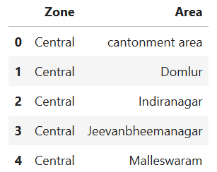

Data after resolving the Latitude and Longitude values

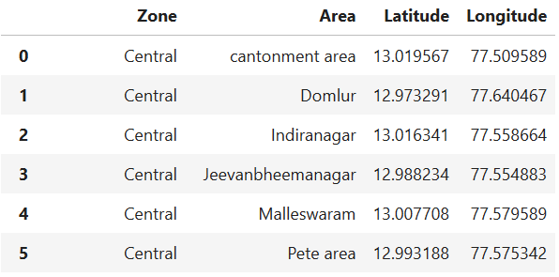

**3. Exploratory Data Analysis**

From the collected Data plot the area location on the Map

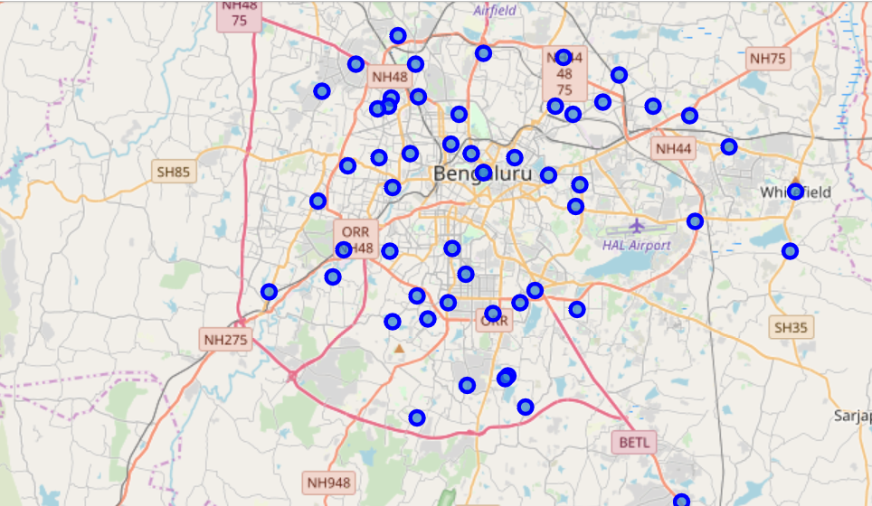

We need to find the Top venues of each area in the Bengaluru. We will feed the data which we collected so far to the Foursquare to get the top 10 venues of each area.

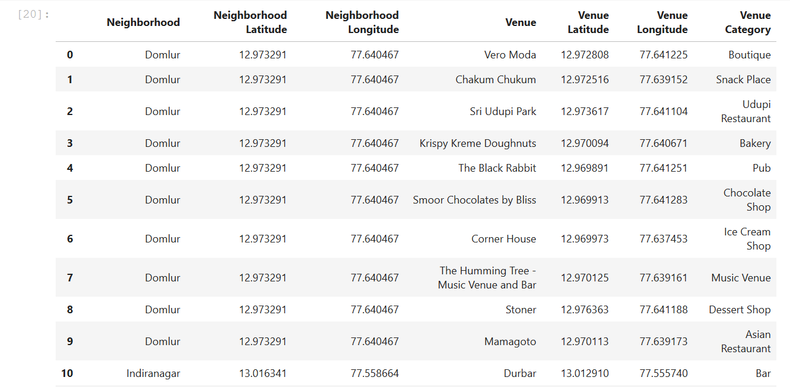

Find top five frequently visiting venues of each area and display the result.

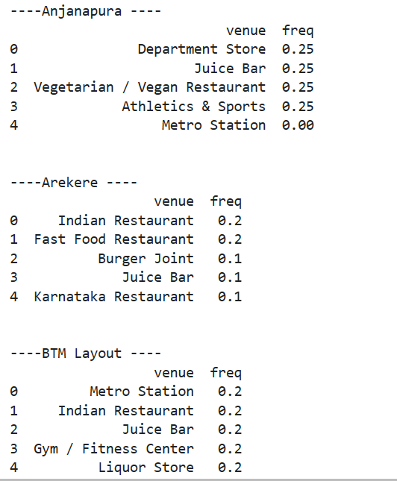

Arrange the Top10 frequently visited venue’s category in the sorted list

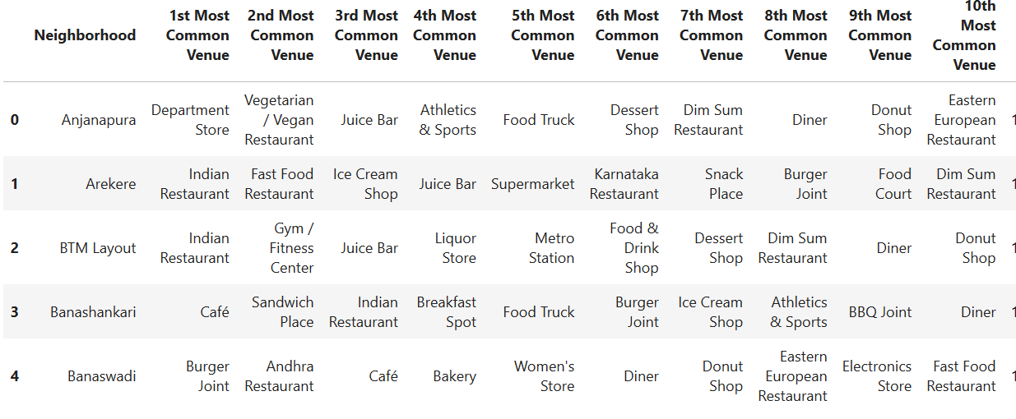

Plot the graph of top10 venues

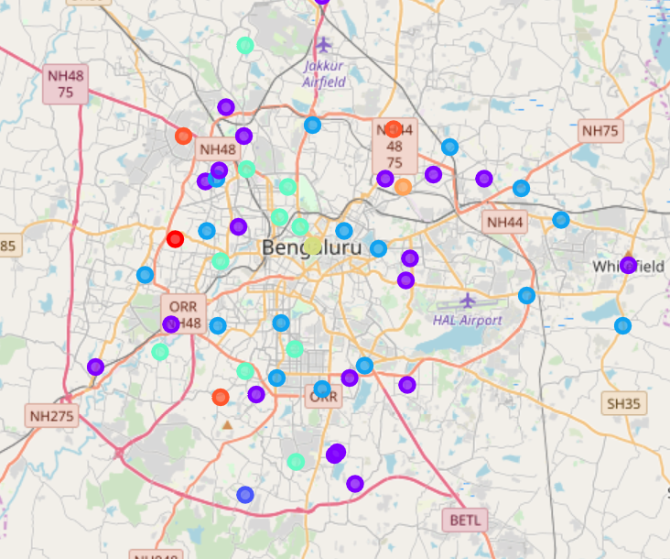

**4. Results**

Filter of the Areas where the Top common visited venues are Indian restaurant

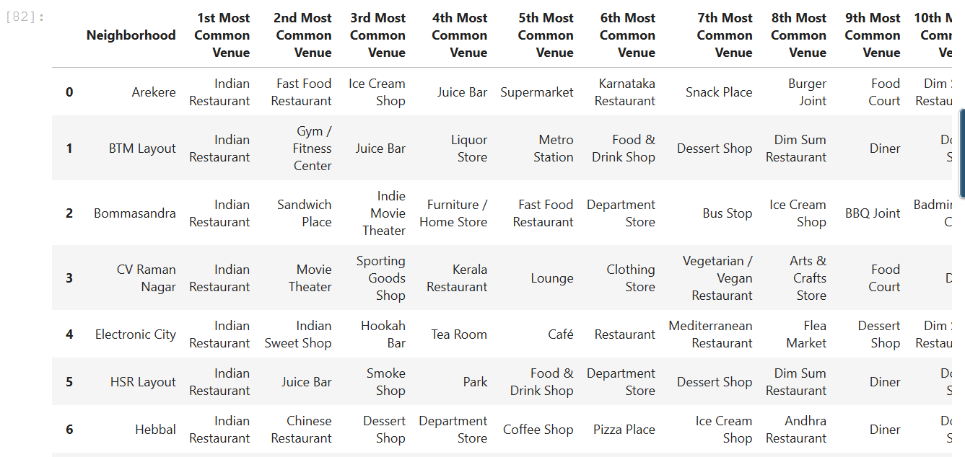

Filter of the Areas where the Top common visited venues are Café

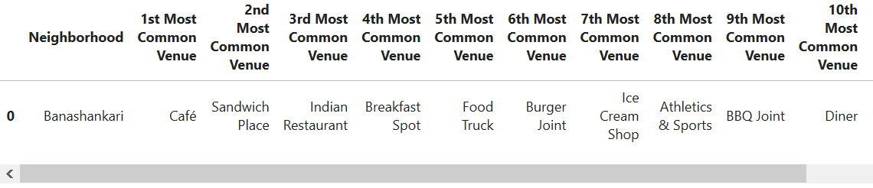

**5. Discussion**

As per our goal we found the locality which has the high frequency of people who visits the Indian restaurant and the Café. As per the analysis, Now I can suggest my friend the locality where he can open his new Indian restaurant and Café.

Further the analysis can be taken further like what are the food which is likes by the locality etc.

**6. Conclusion**

We have the Top 20 Locality which has frequent visitors to Indian Restaurant, based on this my friend can choose the locality where to open his Next restaurant based on other criteria like near to his current restaurant, and availability of the Building/Rent of the building etc.